**UAS Pemrograman Web Services**

**NIM : 1512501170**

**Nama : Nikko Handiarto**

**Kelompok : SI**

**No Absen : 13**

=====================================================================================

**Jawaban :**

1. 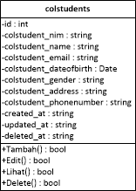Class Diagram untuk table master Mahasiswa
2. ReST list for process Students

Resource:

* 1. POST /colstudents
  2. PUT /colstudents/{id}
  3. DELETE /colstudents/{id}
  4. GET /colstudents

1. REST API Resources untuk master Mahasiswa tersebut agar dapat mengakomodir proses CRUD! (Wajib memanfaatkan Models dan ORM, Transformers, Route, Controllers)

Link Github Dibawah Ini:

<https://github.com/Snikky1505/LumenAPIv5.git>